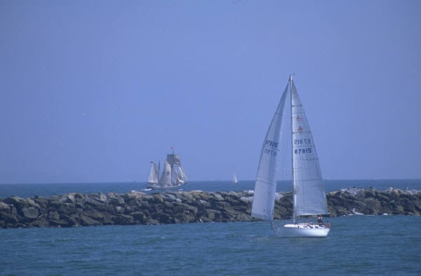

5:00 School Committee-Sparrell
7:00 Open
7:30 Citizen Comments
7:35 Pat Anderson, Town Clerk-Town Meeting & Election Dates

Call to Order
Approval of Minutes
Appointments – Energy Committee Appointment

Old Business – Economic Development Committee

New Business – One Day License Request from North River Theatre

Upcoming Meetings

ROAD OPENINGS
- 146 High Street
- Christopher Road at Pole 2
- 8 Leigh Road
- 152 High Street
- Hall Drive at Pole 10

Announcements
Adjournment

Executive Session

